**Daily Scrum or Standup Meeting**

Team name: _______Hellz Kittens________

Scrum Master: _____Gavin Reid________

Date:___________11-20______________

|  |  |  |  |
| --- | --- | --- | --- |
| **Team Member** | **What did you do since the last scrum?** | **What do you plan to do before the next scrum?** | **What obstacles do you have?** |
| Griffin Hackley | Unit tests | finish unit tests | Time |
| Jack Miranda | login | Place bid page | Understanding others code |
| Laryssa Revelli | Connected Item to auction, Item unit test | Timer test, show winners | collaborating |
| Gavin Reid | Bidding view with constraints | Assign user bidderID | Django n00b |
|  |  |  |  |

# Burndown

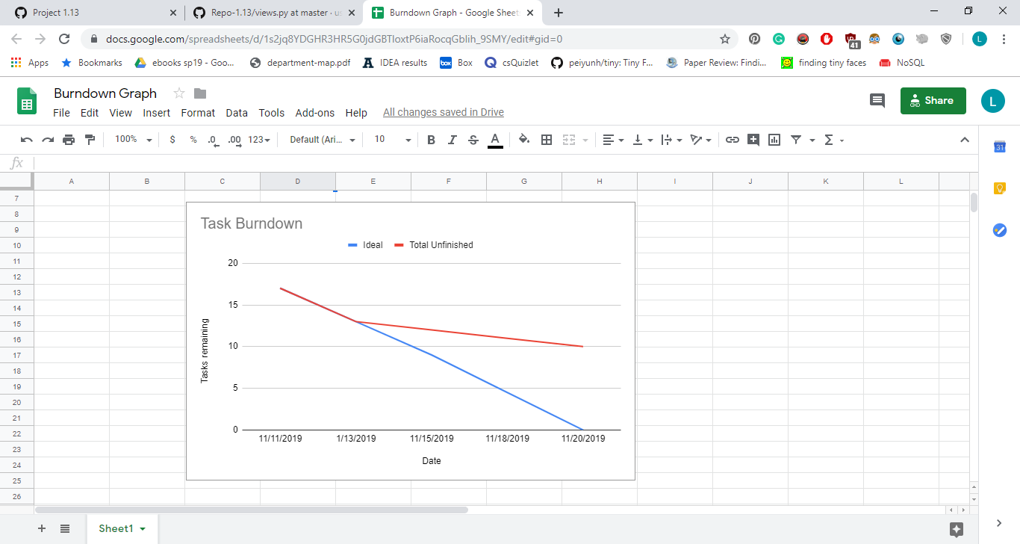

# Screenshot of you project board

